**PROJECT 1: DEPLOYING WEBSITE ON AWS EC2 INSTANCES:**

**Step 1: Create a VPC**

* Log in to the AWS Management Console as an IAM user, select “service” and navigate to “VPC.” You may type “VPC” into the search bar to get there faster.
* Click on the “Create VPC” button
* **Pooja-vpc**

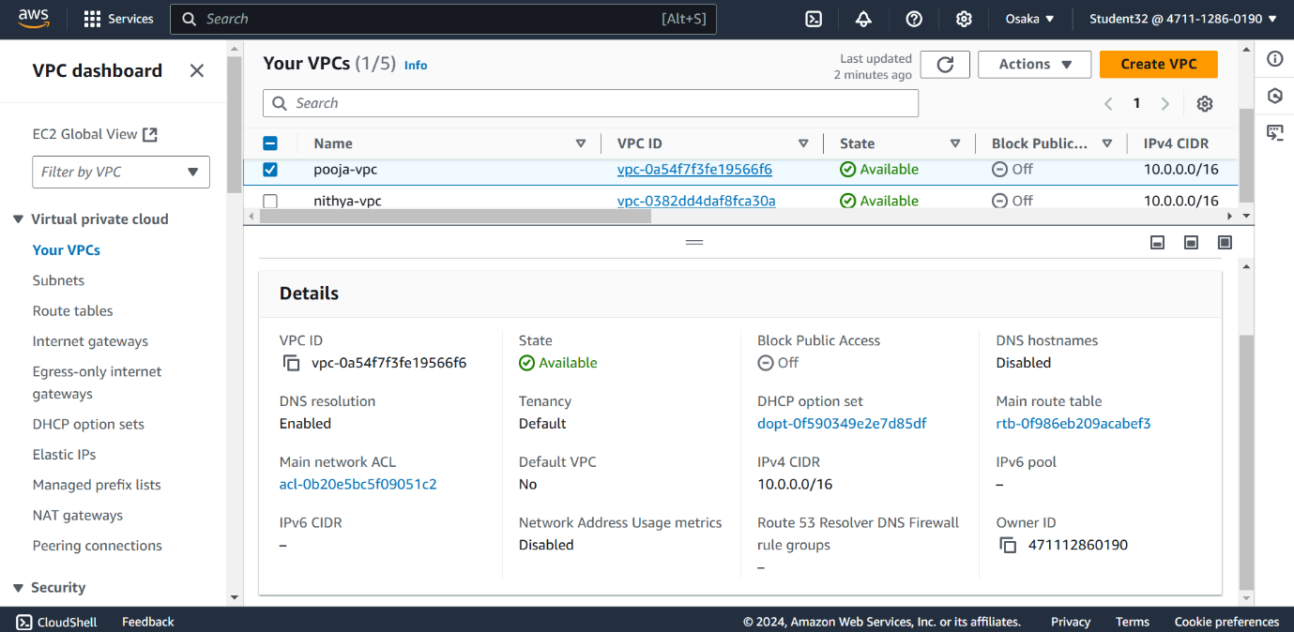

**Step 3: Create Internet Gateway and Route Table:**

* On the left side of the VPC dashboard is a list of options, select Internet Gateway by clicking it. Next, give your Internet Gateway a name and leave everything else as default. Finally, click Finally, click on “Create Internet Gateway.”
* 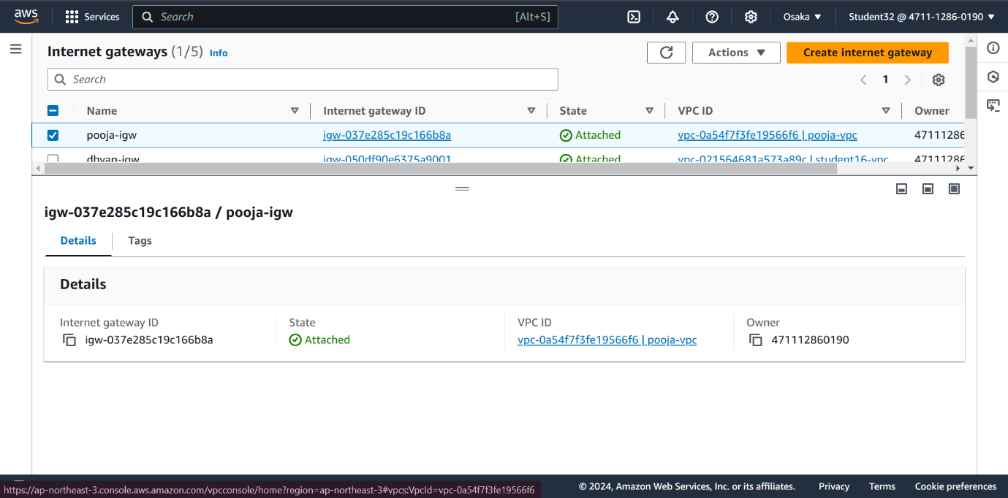Now we will attach this Internet Gateway to the VPC we created earlier. Click on “Actions,” scroll down to “Attach to VPC,” and click on it. Next, search for the Internet Gateway you just created in the search bar and select it. Click on “Attach Internet Gateway.”
* **Pooja-igw**

**Step 3: Create a Public Subnet**

On the left side of the VPC dashboard is a list of options. First, select First, select Subnets by clicking it. Then select Create subnet.

Next, select the VPC you just created for the VPC ID field. Then, give your public subnet a name. Select a region of availability. Select your IPv4 CIDR Block range and click the “Create Subnet” button.

Name: **publicsubnet1** & **publicsubnet2**

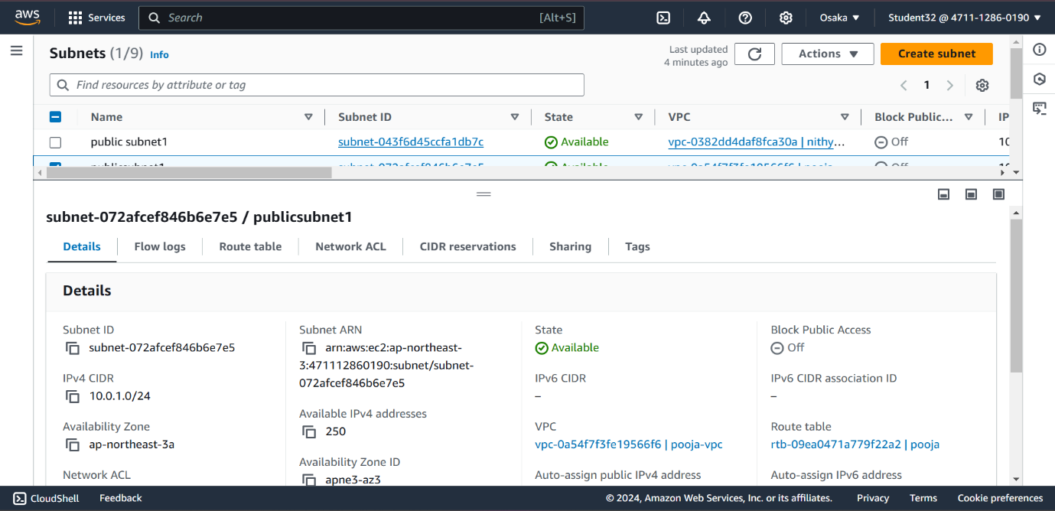

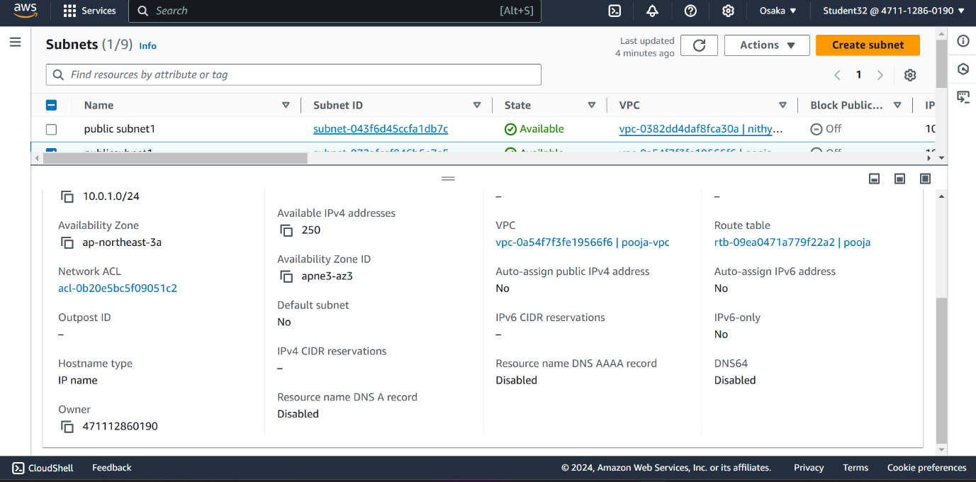

**Now we will configure the Routing within the VPC and Internet Gateway.**

* On the left side of the VPC dashboard is a list of options, select Route Table by clicking it. Next, give your Route Table a name, and in the search bar, attach the VPC we created earlier. Finally, clickFinally, click on “Create Route Table.”
* Check the box next to the Route Table we just created and then click on “Actions.” Scroll down to Edit Routes. Then, put the universal IP address 0.0.0.0/0 in the Edit Route Destination, which means that any IP address can access this internet gateway.
* Now we need to associate this Public Subnet with the Route Table. First, go First, go into your Route Table dashboard and check the box next to your Route Table name. Then, click on the “Subnet Associations” tab. After that, select the available subnets and click on save associations. Now your public subnet will have access to the Internet.

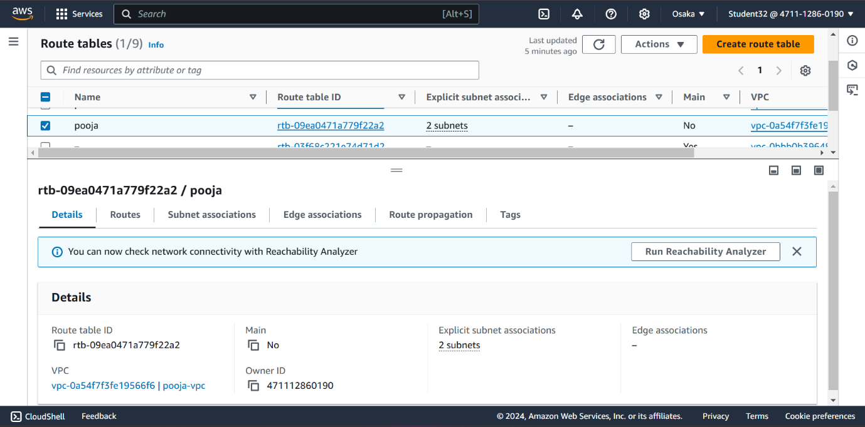

**Step 4: Create an EC2 Instance**

Click on “services” and navigate to “EC2,” or you can type “EC2 in the search bar to get there quicker. Once you are at the EC2 dashboard, click on “Launch Instance.”

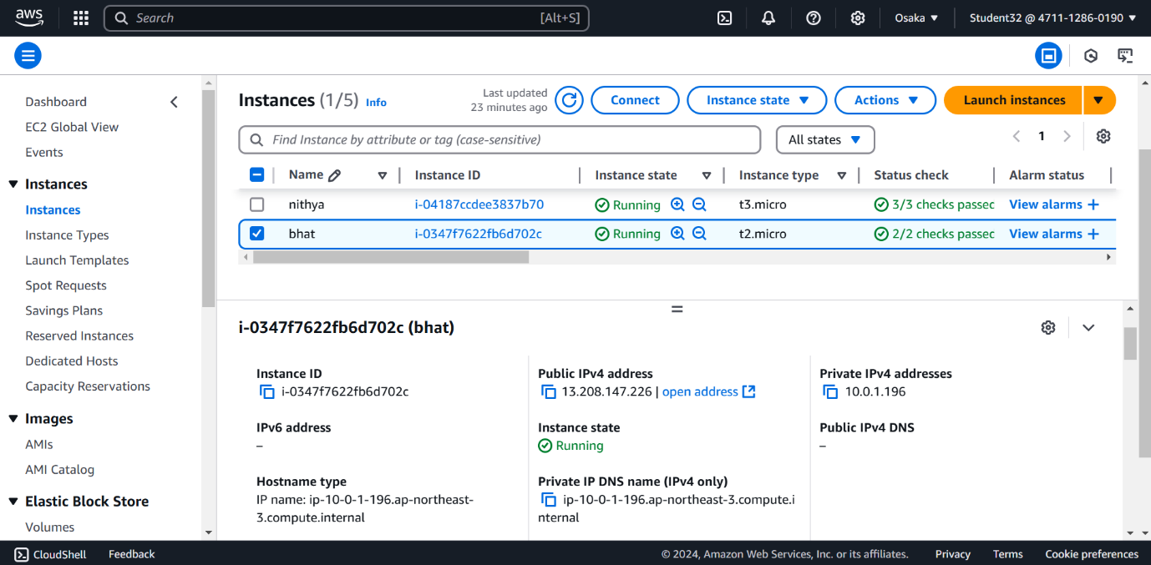

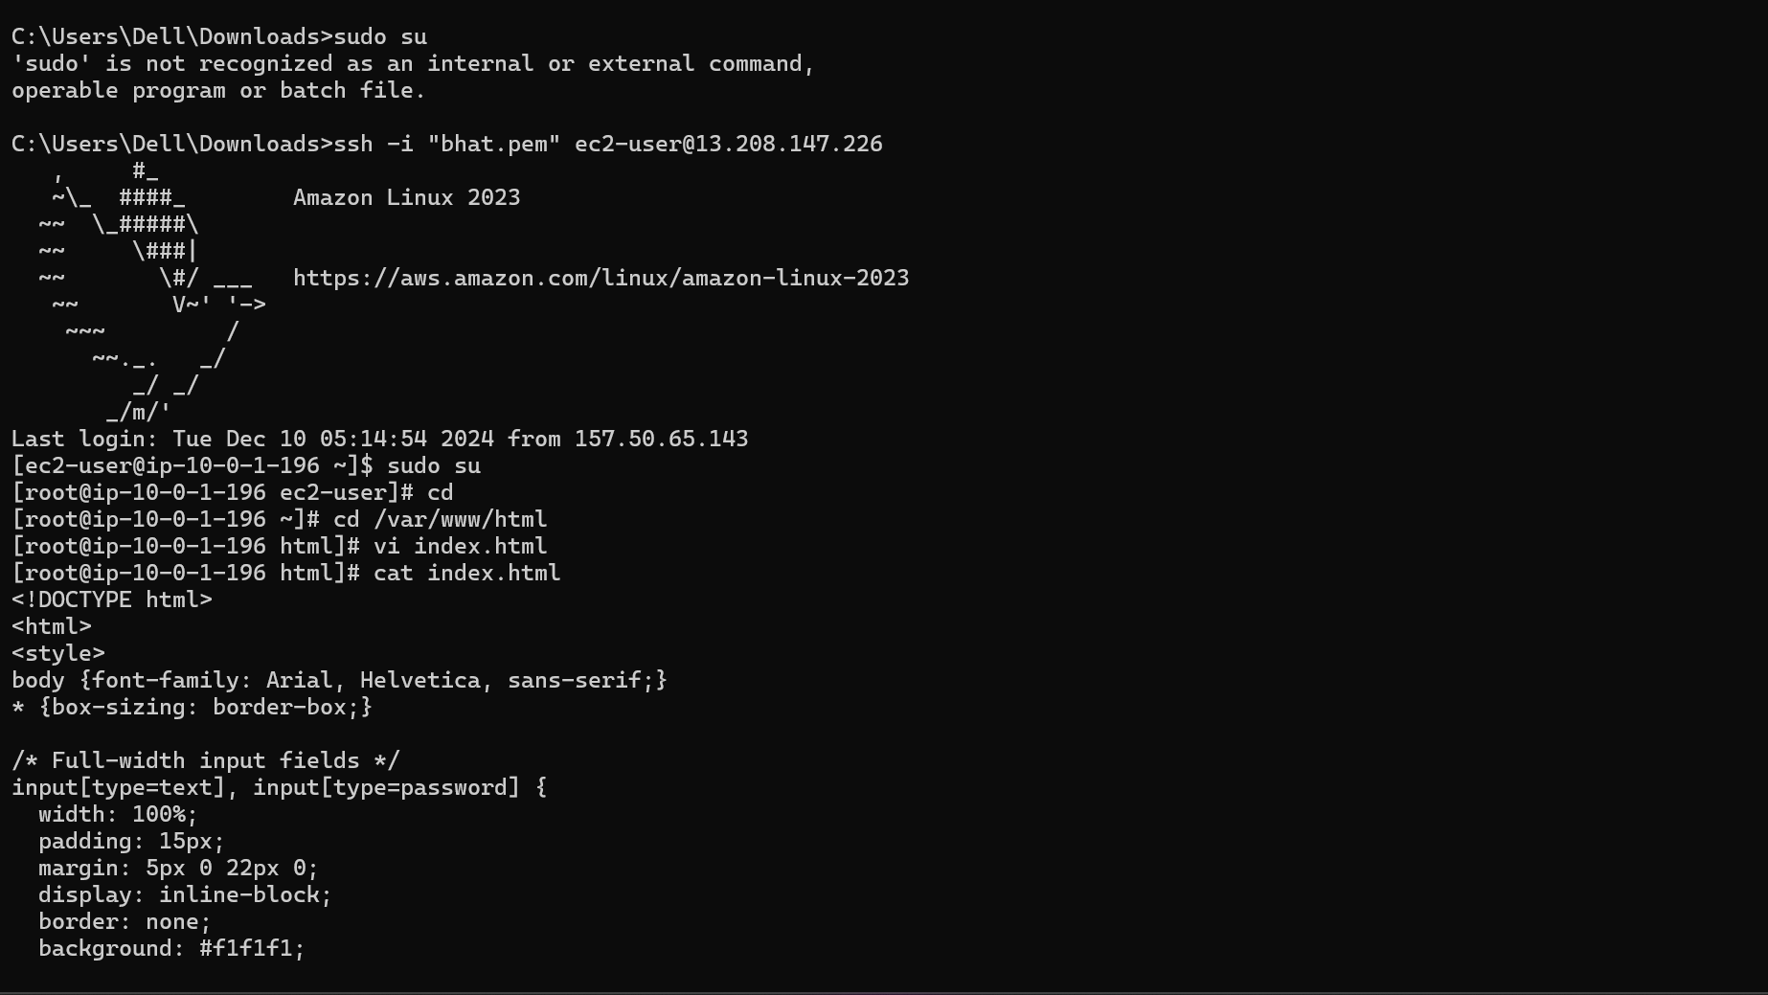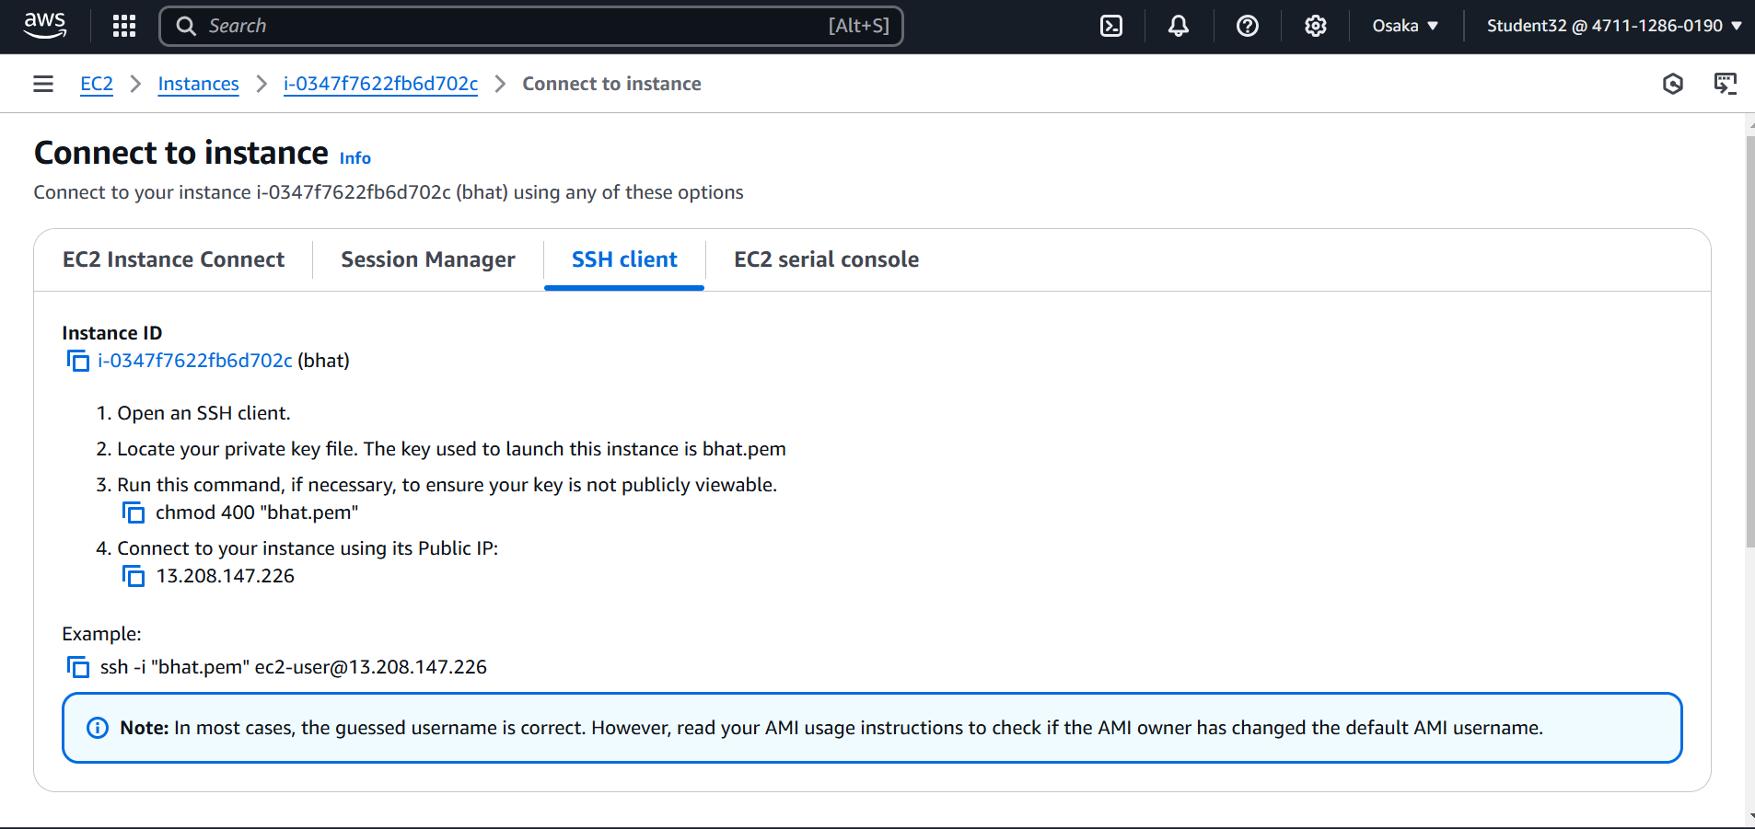

**STEP 5 : COMMADAND PROMPT** -COMMANDS AS BELOW

